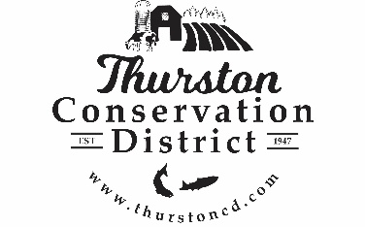
PRESS RELEASE

CONTACT:
Sarah Moorehead
11-21-22 smoorehead@thurstoncd.com

Notice of Potential Quorum

Saturday, October 3, 2026, Harvest Festival
The Board of Supervisors will be attending the Harvest Festival on Saturday October 3th 2026, from 10:00 a.m.– 3:00 p.m. at South Union Grange Hall in Tumwater, WA. A quorum of supervisors will be present. No formal actions will be taken.

www.thurstoncd.com
582 Tilley Ct. SE, Suite 152, Tumwater 98501
Please contact us with any questions:
360.754.3588

