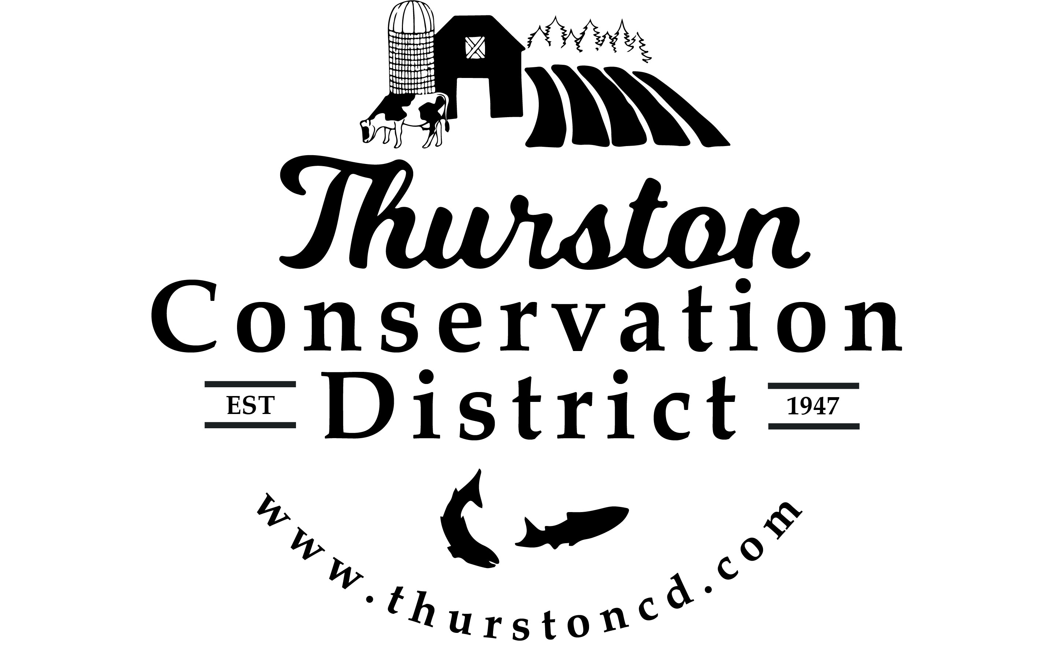
PRESS RELEASE

CONTACT:
Sarah Moorehead
11-21-22 smoorehead@thurstoncd.com

Notice of Potential Quorum

Wednesday, September 4, 2024, Staff & Supervisor Picnic
The Board of Supervisors will be attending an informal staff and supervisor picnic on September 4th 2024, from 4:00 p.m.– 6:00 p.m. at Urban Futures Farm in Olympia, WA. A quorum of supervisors will be present. No formal actions will be taken.

Saturday, October 5, 2024, Harvest Festival
The Board of Supervisors will be attending the annual Harvest Festival on October 5th 2024, from 10:00 a.m.– 3:00 p.m. at South Union Grange Hall in Tumwater, WA. A quorum of supervisors will be present. No formal actions will be taken.

Thursday, October 10, 2024, WACD Southwest Area Meeting
The Board of Supervisors will be attending WACD Southwest Area Meeting on October 10th 2024, from 9:00 a.m. – 3:00 p.m. at Heritage Distilling Company in Tumwater, WA. A quorum of supervisors will be present. No formal actions will be taken.

Thursday, October 17, 2024, Legislative Tour
The Board of Supervisors will be attending a Legislative Tour on October 17th, 2024, from 9:00 a.m. – 3:00 p.m. at various locations throughout Thurston county, WA. A quorum of supervisors will be present. No formal actions will be taken.

Thursday, October 24, 2024, Legislative Tour
The Board of Supervisors will be attending a Legislative Tour on October 24th, 2024, from 9:00 a.m. – 3:00 p.m. at various locations throughout Thurston county, WA. A quorum of supervisors will be present. No formal actions will be taken.

Thursday, December 2-4, 2024, WACD Annual Meeting and Conference
The Board of Supervisors will be attending the WACD Annual Meeting and Conference on December 2nd- 4th 2024, at the Northern Quest Resort & Casino in Spokane, WA. A quorum of supervisors will be present. No formal actions will be taken.

Please contact us with any questions:
360.754.3588

